# Aim: To design an interactive dashboard using Tableau

**IDE: Tableau**

# Theory:

After you've created one or more sheets, you can combine them in a dashboard, add interactivity, and much more.

You create a dashboard in much the same way you create a new worksheet. At the bottom of the workbook, click the **New Dashboard** icon:



From the **Sheets** list at left, drag views to your dashboard at right.

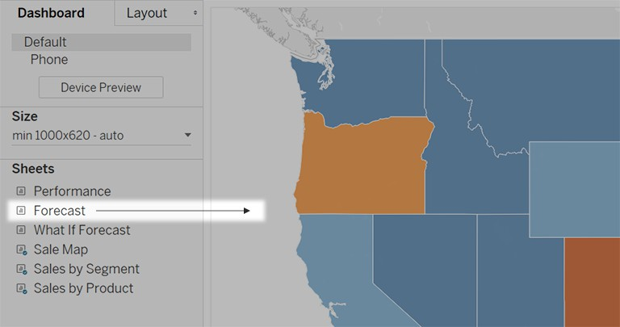

To replace a sheet, select it in the dashboard at right. In the Sheets list at left, hover over the replacement sheet, and click the **Swap Sheets** button.

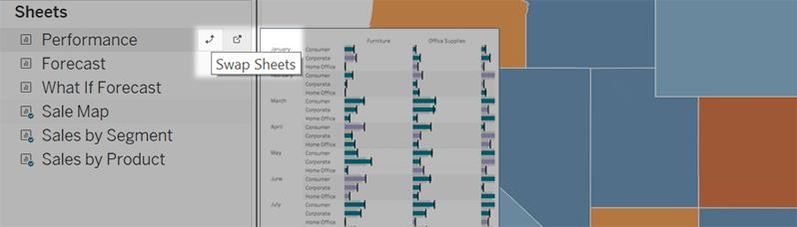

**Note:** When you replace a sheet, Tableau retains any padding, border, or background color. However, you may need to adjust sheet size if content differs significantly. You may also need to delete dashboard items specific to the previous sheet, such as filters, which become blank.

# Add interactivity

You can add interactivity to dashboards to enhance users' data insights. Try these techniques:

In the upper corner of sheet, enable the **Use as Filter** option to use selected marks in the sheet as filters for other sheets in the dashboard.

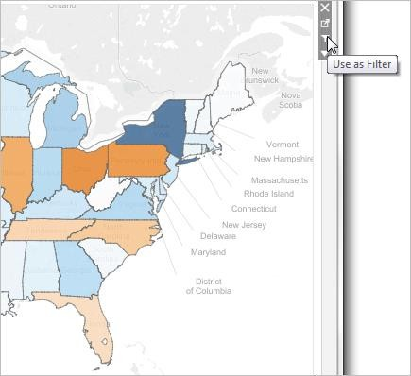

When authoring in Tableau Desktop, add actions to use multiple sheets as filters, navigate from one sheet to another, display web pages, and more. For details, see [Actions and Dashboards](https://help.tableau.com/current/pro/desktop/en-us/actions_dashboards.htm).

**Add dashboard objects and set their options**

In addition to sheets, you can add dashboard objects that add visual appeal and interactivity. Here's guidance about each type:

**Horizontal** and **Vertical** objects provide [layout containers](https://help.tableau.com/current/pro/desktop/en-us/dashboards_refine.htm#Use_a_layout_container) that let you group related objects together and fine- tune how your dashboard resizes when users interact with them.

**Text** objects can provide headers, explanations, and other information.

**Image** objects add to the visual flavor of a dashboard, and you can link them to specific target URLs. (While Web Page objects can also be used for images, they are better for complete web pages. The Image object provides image-specific fitting, linking, and alt-text options.)

**Web Page** objects display target pages in the context of your dashboard. Be sure to review these web security options, and be aware that some web pages don't allow themselves to be embedded—Google is one example.

**Blank** objects help you adjust spacing between dashboard items.

**Navigation** objects let your audience navigate from one dashboard to another, or to other sheets or stories. You can display text or an image to indicate the button's destination to your users, specify custom border and background colors, and provide informational tooltips.

**Download** objects let your audience quickly create a PDF file, PowerPoint slide, or PNG image of an entire dashboard, or a crosstab of selected sheets. Formatting options are similar to Navigation objects.

**Extension** objects let you add unique features to dashboards or integrate them with applications outside Tableau.

**Ask Data** objects let users enter conversational queries for specific data source fields, which authors optimize for specific audiences such as sales, marketing, and support staff.

# Add an object

From the **Objects** section at left, and drag an item to the dashboard on the right:

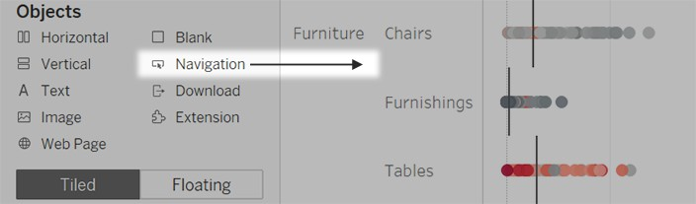

# Copy objects

You can copy and paste objects either within the current dashboard, or from dashboards in other sheets and files. You can even copy objects between Tableau Desktop and Tableau in your web browser.

You can't, however, copy the following:

Sheets in a dashboard

Items that rely on a specific sheet, such as filters, parameters, and legends

Layout containers with something you can't copy inside them, like a sheet or filter Objects on a device layout

Dashboard titles

Select a dashboard object, and from the object menu, select **Copy Dashboard Item**. Or from the main menu, select **Dashboard** > **Copy Selected Dashboard Item**.

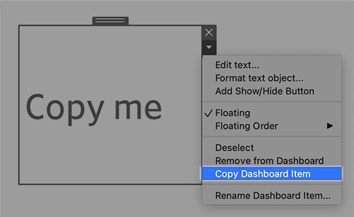

Go to the dashboard where you want to paste the object. Then either select nothing to paste in the upper-left corner of the dashboard, or select an existing item to paste next to.

In Tableau Desktop, choose **File** > **Paste**. In a browser, either choose **Edit** > **Paste** or use the keyboard shortcut for pasting.

The object is pasted 10 pixels below and to the right of the upper-left corner of the dashboard or the selected object. To move the pasted object, drag the handle at the top.



# Pre Lab Exercise:

1. What is a dashboard in Tableau?
2. Explain the importance of designing effective dashboards.
3. What are the key components of a Tableau dashboard?

# Pre Lab Tasks:

Perform the following tasks using Excel:

Task 1: Take a dataset and create at least 4 different representations.

# Results:-

Task 2: Create an interactive dashboard from those representations.

# Results:-

# In Lab Tasks:

Perform the following tasks using Tableau:

Task 1: Take a dataset and create at least 4 different representations.

# Results:-

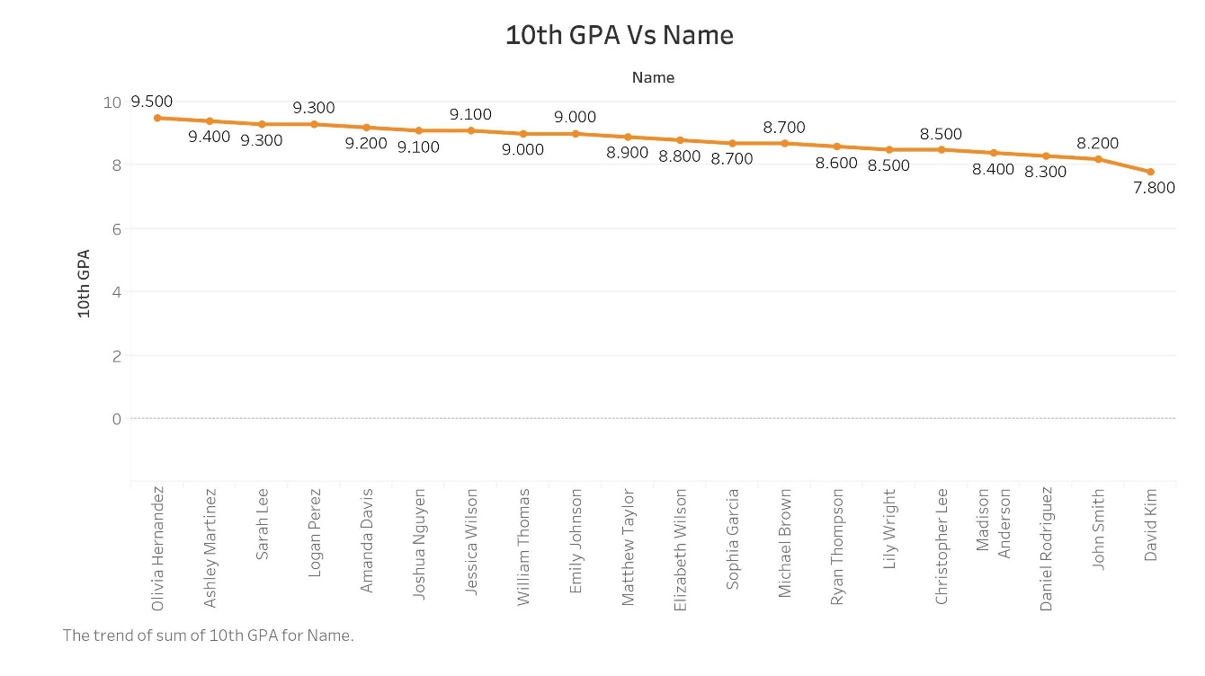

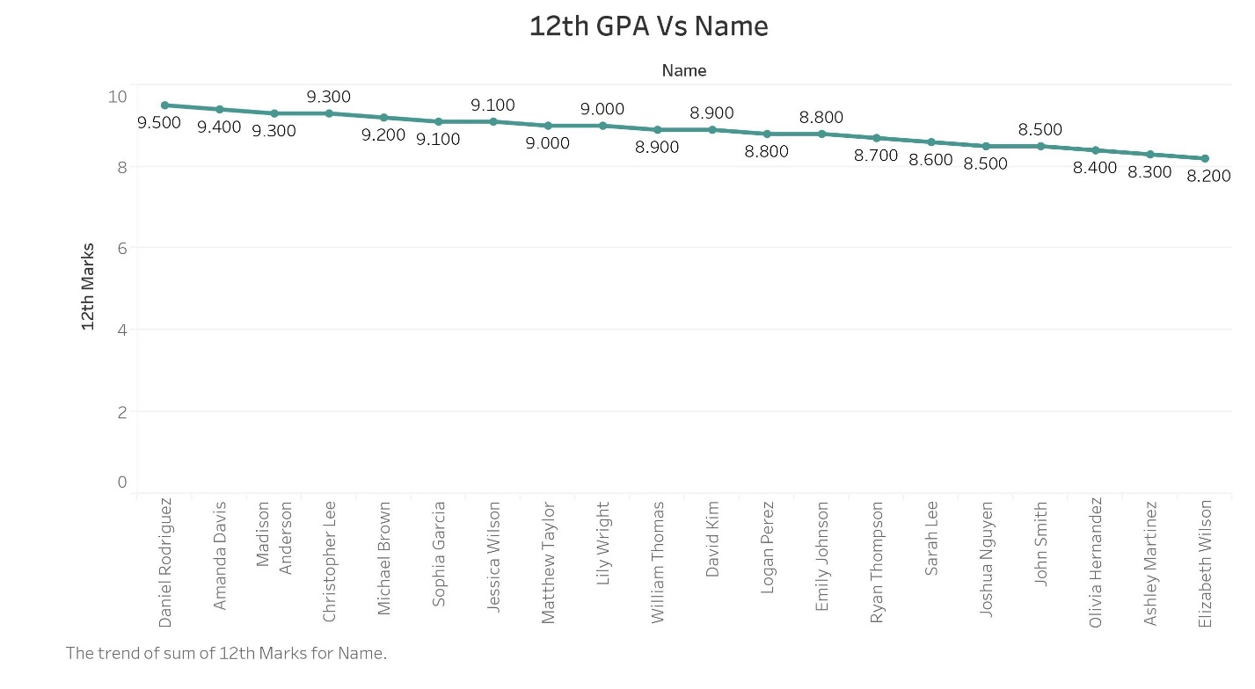

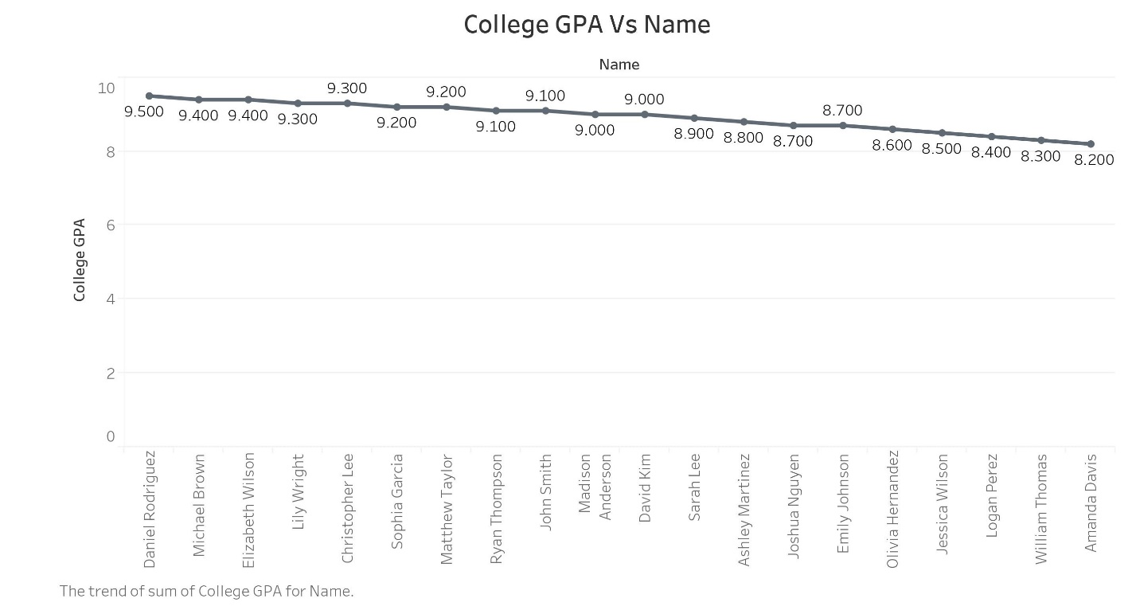

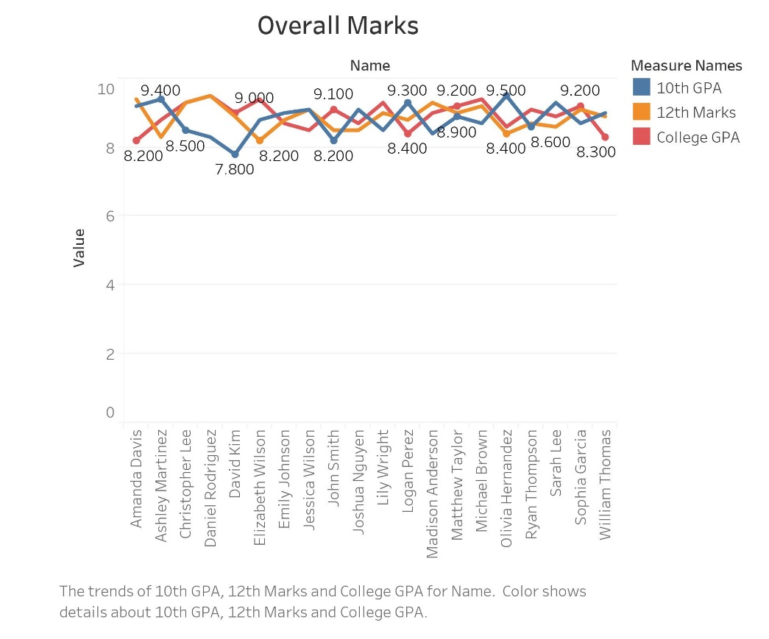

Task 2: Create an interactive dashboard from those representations.

# Results:-

# Post Lab Tasks:

Perform the following tasks using Python:

**Pre-Requisites :-**

import pandas as pd

import plotly.express as px

import plotly.graph_objects as go

from plotly.subplots import make_subplots

Dataset = pd.read_excel('./Dataset.xlsx' , 'Sheet1')

Task 1: Take a dataset and create at least 4 different representations.

**Code :-**

# Figure - 1

Dataset['10th GPA Text'] = Dataset['10th GPA'].astype(str)

Figure_1 = px.line(data_frame=Dataset, x="Name", y="10th GPA", text='10th GPA Text', labels={'Name': 'Student Name', '10th GPA': '10th GPA'}, title='10th Result')

Figure_1.update_traces(textposition='top right')

Figure_1.update_traces(line=dict(color='red'))

Figure_1.write_html('Plot-1.html', auto_open=True)

# Figure - 2

Dataset['12th GPA Text'] = Dataset['12th GPA'].astype(str)

Figure_2 = px.line(data_frame=Dataset, x="Name", y="12th GPA", text='12th GPA Text', labels={'Name': 'Student Name', '12th GPA': '12th GPA'}, title='12th Result')

Figure_2.update_traces(textposition='top right')

Figure_2.update_traces(line=dict(color='green'))

Figure_2.write_html('Plot-2.html', auto_open=True)

# Figure - 3

Dataset['College GPA Text'] = Dataset['College GPA'].astype(str)

Figure_3 = px.line(data_frame=Dataset, x="Name", y="College GPA", text='College GPA', labels={'Name': 'Student Name', 'College GPA': 'College GPA'}, title='College Result')

Figure_3.update_traces(textposition='top right')

Figure_3.update_traces(line=dict(color='orange'))

Figure_3.write_html('Plot-3.html', auto_open=True)

# Figure - 4

Dataset['10th GPA Text'] = Dataset['10th GPA'].astype(str)

Dataset['12th GPA Text'] = Dataset['12th GPA'].astype(str)

Dataset['College GPA Text'] = Dataset['College GPA'].astype(str)

Figure_4 = go.Figure()

Figure_4.add_trace(go.Scatter(x=Dataset['Name'], y=Dataset['10th GPA'],mode='markers+lines',name='10th Result',text=Dataset['10th GPA Text'], textposition="top center" ))

Figure_4.add_trace(go.Scatter(x=Dataset['Name'], y=Dataset['12th GPA'],mode='markers+lines',name='12th Result',text=Dataset['12th GPA Text'],textposition="top center"))

Figure_4.add_trace(go.Scatter(x=Dataset['Name'], y=Dataset['College GPA'],mode='markers+lines',name='College Result',text=Dataset['College GPA Text'],textposition="top center"))

Figure_4.update_layout(xaxis_title='Student Name',yaxis_title='GPA',title='10th, 12th, and College Result')

Figure_4.write_html('Plot-4.html' , auto_open=True)

# Results:-

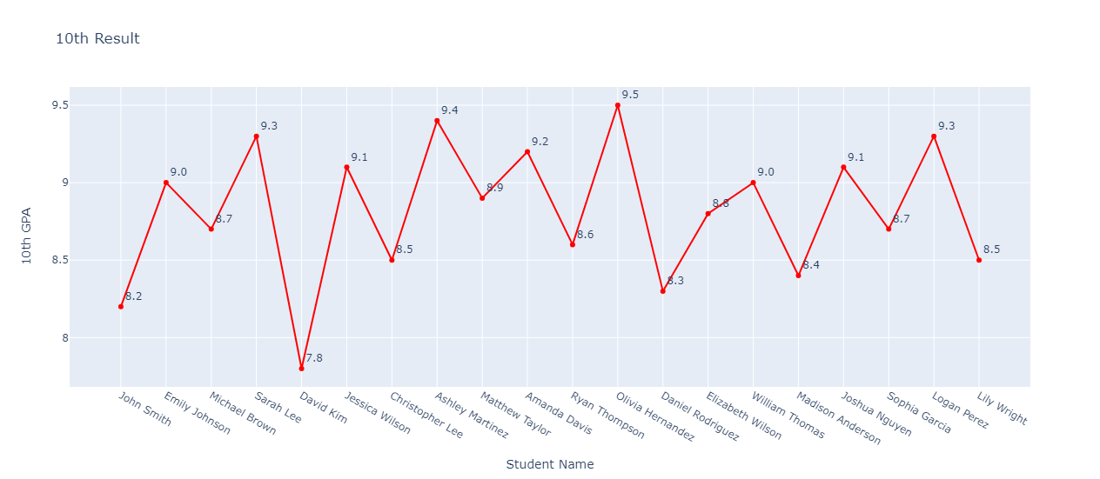

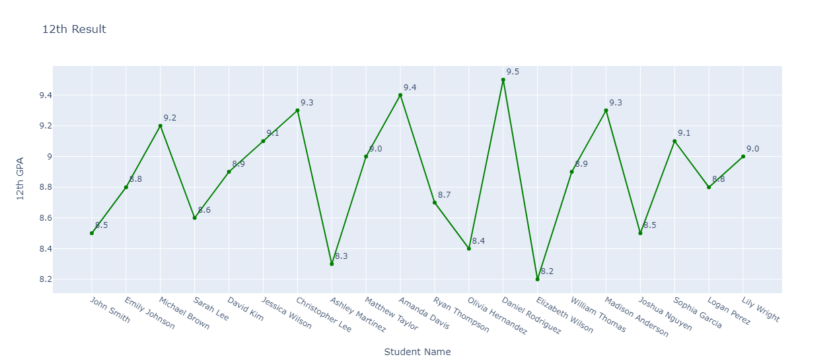

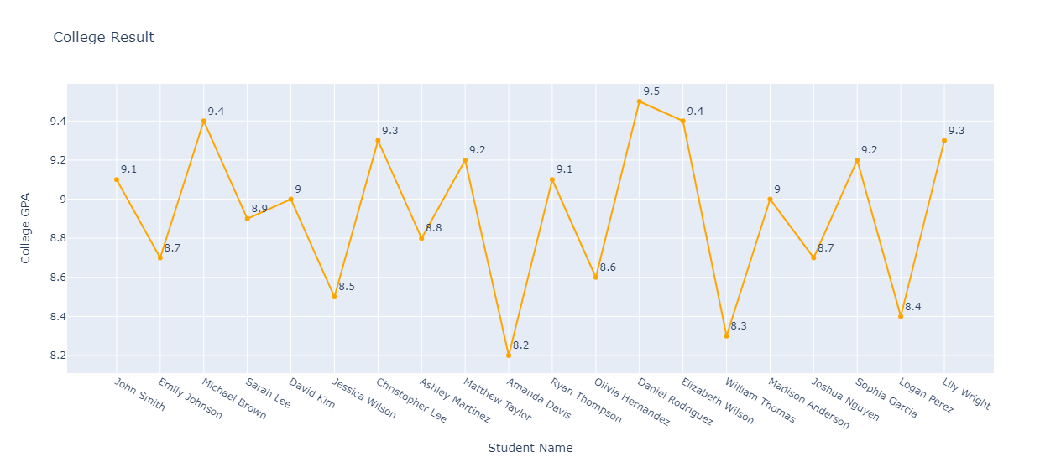

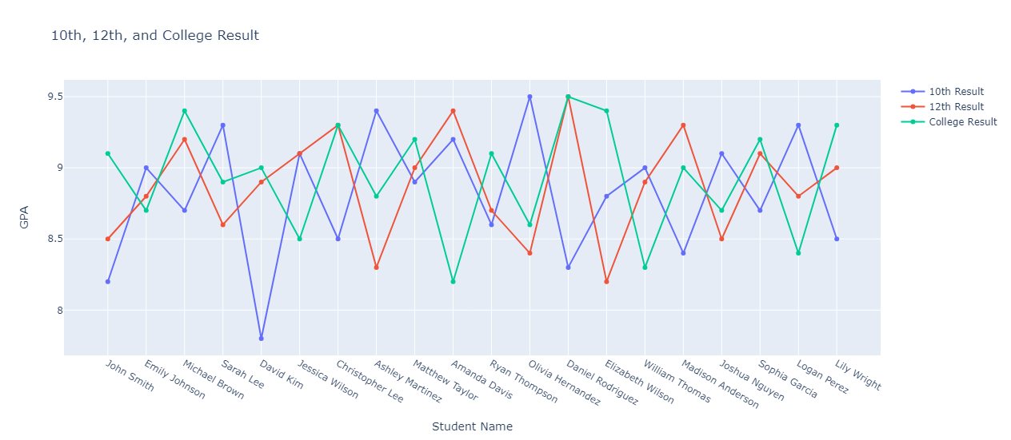

Task 2: Create an interactive dashboard from those representations.

**Code :-**

Dataset['10th GPA Text'] = Dataset['10th GPA'].astype(str)

Figure_1 = px.line(data_frame=Dataset, x="Name", y="10th GPA", text='10th GPA Text', labels={'Name': 'Student Name', '10th GPA': '10th GPA'}, title='10th Result')

Figure_1.update_traces(textposition='top right')

Figure_1.update_traces(line=dict(color='red'))

Dataset['College GPA Text'] = Dataset['College GPA'].astype(str)

Figure_2 = px.line(data_frame=Dataset, x="Name", y="College GPA", text='College GPA', labels={'Name': 'Student Name', 'College GPA': 'College GPA'}, title='College Result')

Figure_2.update_traces(textposition='top right')

Figure_2.update_traces(line=dict(color='orange'))

Dataset['12th GPA Text'] = Dataset['12th GPA'].astype(str)

Figure_3 = px.line(data_frame=Dataset, x="Name", y="12th GPA", text='12th GPA Text', labels={'Name': 'Student Name', '12th GPA': '12th GPA'}, title='12th Result')

Figure_3.update_traces(textposition='top right')

Figure_3.update_traces(line=dict(color='green'))

Figure_4 = go.Figure()

Figure_4.add_trace(go.Scatter(x=Dataset['Name'], y=Dataset['10th GPA'],mode='markers+lines',name='10th Result',text=Dataset['10th GPA Text'], textposition="top center"))

Figure_4.add_trace(go.Scatter(x=Dataset['Name'], y=Dataset['12th GPA'],mode='markers+lines',name='12th Result',text=Dataset['12th GPA Text'], textposition="top center"))

Figure_4.add_trace(go.Scatter(x=Dataset['Name'], y=Dataset['College GPA'],mode='markers+lines',name='College Result',text=Dataset['College GPA Text'],textposition="top center"))

Figure_4.update_layout(xaxis_title='Student Name',yaxis_title='GPA',title='10th, 12th, and College Result')

DashBoard = make_subplots(rows=2, cols=2, subplot_titles=("10th Result", "12th Result", "College Result", "Custom Result"))

DashBoard.add_trace(Figure_1.data[0], row=1, col=1)

DashBoard.add_trace(Figure_2.data[0], row=1, col=2)

DashBoard.add_trace(Figure_3.data[0], row=2, col=1)

for trace in Figure_4.data:

DashBoard.add_trace(trace, row=2, col=2)

DashBoard.update_layout(height=600, width=800, title_text="Student GPA Results Dashboard")

DashBoard.write_html('Dash_Board.html', auto_open = True)

# Results:-

# Observation and Result Analysis:

Write the final observation and process corresponding to each task

**1. How the dashboard view makes the analysis easier in your dataset?**

# Post Lab Exercise:

**Exercise 1:** Make your small dataset, which has at least 20 observations (rows) and 8 features (columns). Make a line chart, histogram chart, pie chart, and scatterplot from that dataset. Then make the dashboard from all four charts.

**Pre-Requisites :-**

import pandas as pd

import plotly.express as px

import plotly.graph_objects as go

from plotly.subplots import make_subplots

Dataset = pd.read_excel("./Exercise_1.xlsx",'Sheet1')

Dataset['Percentage'] = (Dataset['PS'] + Dataset['OS'] + Dataset['MCI'] + Dataset['IWT'] + Dataset['DVD'] + Dataset['ADC'] + Dataset['DMS'] + Dataset['Open Elective']) / 8

print(Dataset)

1. **Line Chart :-**

**Code :-**

Dataset["PS Text"] = Dataset["PS"].astype(str)

Line_Chart = px.line(data_frame=Dataset,x="Student",y="PS",text="PS Text",labels={"Name": "Student Name", "PS": "PS Score"},title="PS Result")

Line_Chart.update_traces(textposition="top right")

Line_Chart.update_traces(line=dict(color="red"))

Line_Chart.write_html("Line Chart.html", auto_open=True)

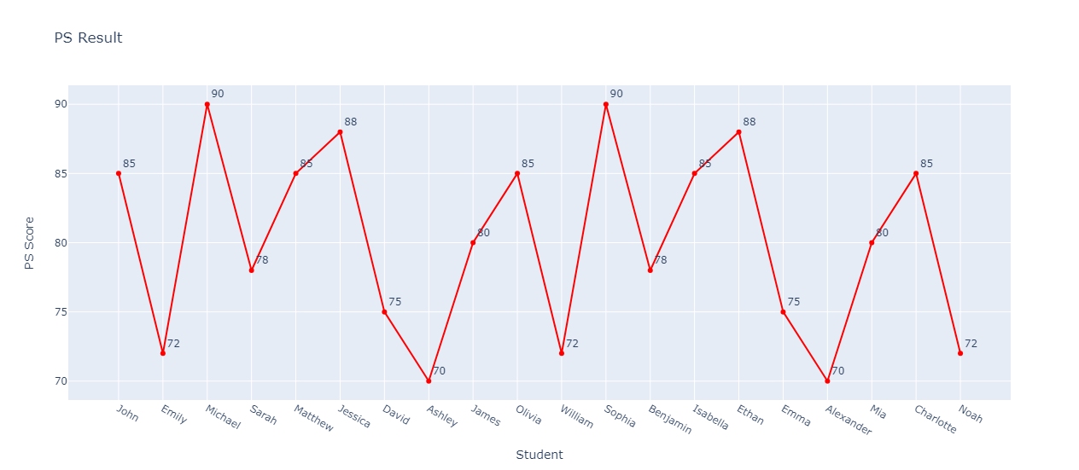**Output :-**

1. **Histogram:-**

**Code:-**

Histo_Distribution = Dataset['Percentage'].value_counts()

labels = Histo_Distribution.index

values = Histo_Distribution.values

Histogram = go.Figure(data=[go.Histogram(x=Histo_Distribution.index)])

Histogram.update_layout(title_text="Histogram of Percentage Distribution")

Histogram.write_html('Histogram.html',auto_open = True)

**Output :-**

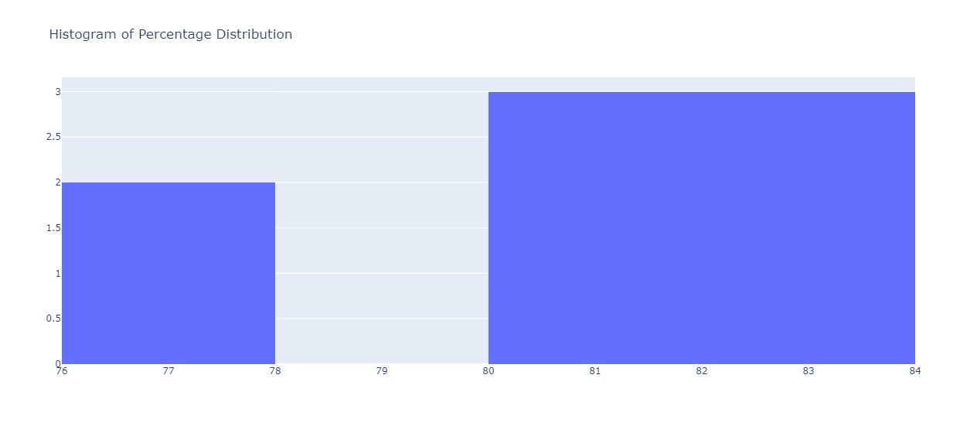

1. **Pie Chart :-**

**Code :-**

Pie_Distribution = Dataset["Percentage"].value_counts()

labels = Histo_Distribution.index

values = Histo_Distribution.values

Pie_Chart = go.Figure(data=[go.Pie(labels=labels, values=values)])

Pie_Chart.update_layout(title_text="Pie Chart of Percentage Distribution")

Pie_Chart.write_html('Pie_Chart.html' , auto_open = True)

**Output :-**

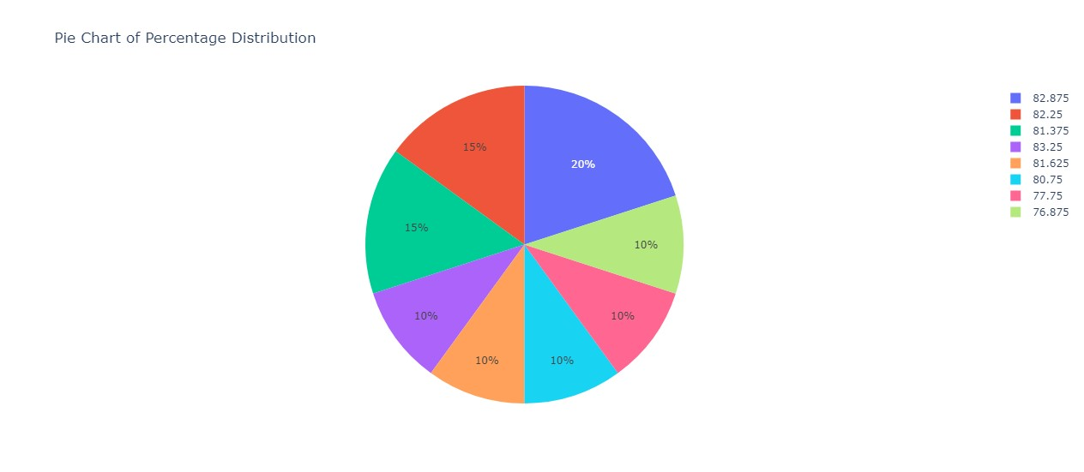

1. **Scatter Plot :-**

**Code :-**

Scatter_Plot = go.Figure(data=go.Scatter(x = Dataset['Student'] , y = Dataset['DVD'] , mode='markers'))

Scatter_Plot.update_layout(title = 'Scatter Plot' , xaxis_title = 'Student Name' , yaxis_title = 'DVD Score')

Scatter_Plot.write_html('Scatter Plot.html',auto_open = True)

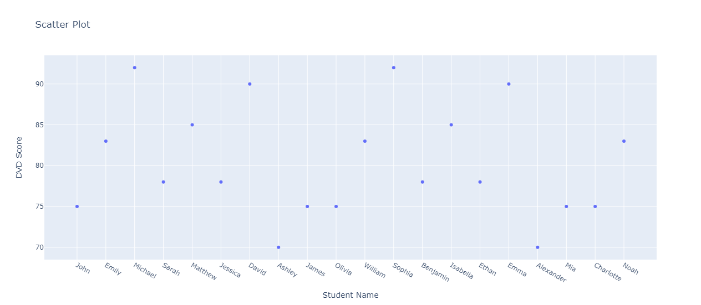**Output :-**

**Dash Board :-**

**Code :-**

Line_Chart = go.Figure()

Line_Chart.add_trace(

go.Scatter(

x=Dataset["Student"],

y=Dataset["PS"],

mode="lines+markers",

text=Dataset["PS Text"],

name="PS Score",

)

)

Line_Chart.update_traces(textposition="top right")

Line_Chart.update_traces(line=dict(color="red"))

Line_Chart.update_layout(

title="PS Result", xaxis_title="Student Name", yaxis_title="PS Score"

)

Histo_Distribution = Dataset["Percentage"].value_counts()

Histogram = go.Figure(data=[go.Histogram(x=Histo_Distribution.index)])

Histogram.update_layout(title_text="Histogram of Percentage Distribution")

Scatter_Plot = go.Figure(

data=go.Scatter(x=Dataset["Student"], y=Dataset["DVD"], mode="markers")

)

Scatter_Plot.update_layout(

title="Scatter Plot", xaxis_title="Student Name", yaxis_title="DVD Score"

)

Pie_Distribution = Dataset["Percentage"].value_counts()

Pie_Chart = go.Figure(

data=[go.Pie(labels=Pie_Distribution.index, values=Pie_Distribution.values)]

)

Pie_Chart.update_layout(title_text="Pie Chart of Percentage Distribution")

DashBoard = make_subplots(

rows=3, cols=2,

specs=[[{'type': 'scatter'}, {'type': 'histogram'}],

[{'type': 'scatter'}, None],

[None, {'type': 'pie'}]],

subplot_titles=("Line Chart", "Histogram", "Scatter Plot", "Pie Chart")

)

DashBoard.add_trace(Line_Chart["data"][0], row=1, col=1)

DashBoard.add_trace(Histogram["data"][0], row=1, col=2)

DashBoard.add_trace(Scatter_Plot["data"][0], row=2, col=1)

DashBoard.add_trace(Pie_Chart["data"][0], row=3, col=2)

DashBoard.update_layout(height=600, width=800, title_text="Dashboard")

DashBoard.write_html("Dash Board.html", auto_open=True)

**Output :-**

